**ABSTRACT**

Due to the rise and rapid growth of E-Commerce, use of credit cards for online purchases has dramatically increased and it caused an explosion in the credit card fraud. As credit card becomes the most popular mode of payment for both online as well as regular purchase, cases of fraud associated with it are also rising.

Our project Credit card fraud detection presents a survey of various techniques used in credit card fraud detection mechanisms and evaluates each methodology based on certain design criteria. Fraudulent transactions are scattered with genuine transactions and simple pattern matching techniques are not often sufficient to detect those frauds accurately. Implementation of efficient fraud detection systems has thus become imperative for all credit card issuing banks to minimize their losses. Many modern techniques based on Artificial Intelligence, Data mining, Fuzzy logic, Machine learning, Sequence Alignment, Genetic Programming etc., has evolved in detecting various credit card fraudulent transactions. A clear understanding on all these approaches will certainly lead to an efficient credit card fraud detection system.

**MODULES:**

* User Module
* Admin Module

**MODULES DESCSRIPTION:**

**User:**

User need to give all the detail in the registration form to get registered with the application. User can get login with a valid username and password. User can add card details and can add money in the card. User can view the details of the money available in his card. User can view all the products available in the application and can purchase the products.

**Admin:**

Admin can get login by entering unique username and password.

Admin will add all the details of the products.Admin can view the details of the fraud users and can block them if necessary.

**EXISTING SYSTEM**:

The Traditional detection method mainly depends on database system and the education of customers, which usually are delayed, inaccurate and not in-time. After that methods based on discriminate analysis and regression analysis are widely used which can detect fraud by credit rate for cardholders and credit card transaction for a large amount of data it is not efficient.

**PROPOSED SYSTEM:**

In the proposed system, high amount of losses due to fraud and the awareness of the relation between loss and the available limit have to be reduced. Number of fraud will be deducted and the number of false alert has to be minimized which consumes less time and takes no physical effort. The fraud is detected based on the customer’s behavior. A new classification problem which has a variable misclassification cost is introduced.

**SYSTEM REQUIREMENTS**

**HARDWARE REQUIREMENTS:**

* System : Pentium IV 2.4 GHz.
* Hard Disk : 200 GB.
* Floppy Drive : 1.44 Mb.
* Monitor : 15 VGA Colour.
* Mouse : Logitech.
* Ram : 1 GB.

**SOFTWARE REQUIREMENTS:**

* Operating system : Windows XP/7.
* Coding Language : Java
* Tool : Netbeans
* Database : MYSQL

.

**CHAPTER: 6**

**SCREEN SHOTS**

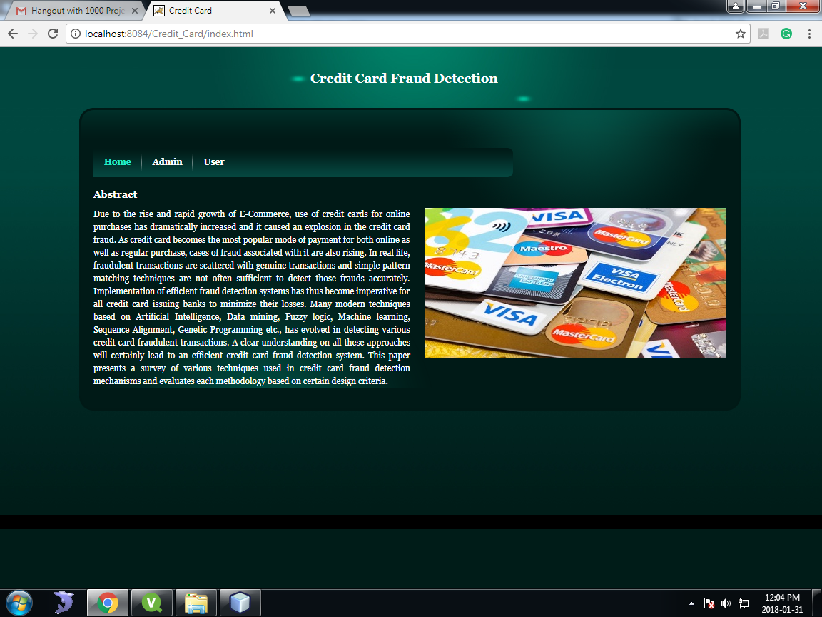

Fig: Home Page

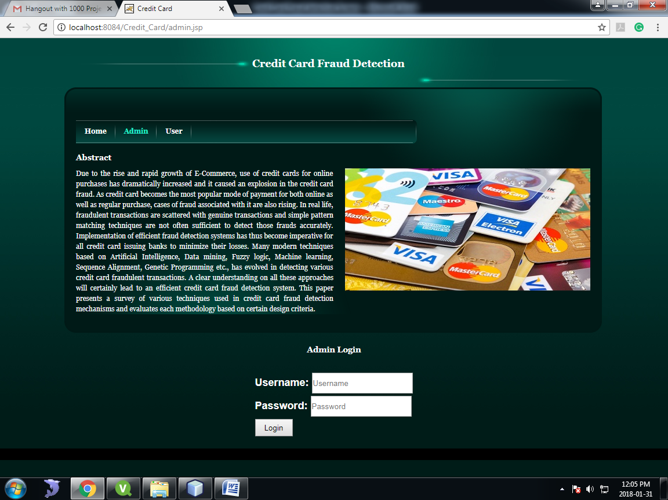

Fig: Admin Login

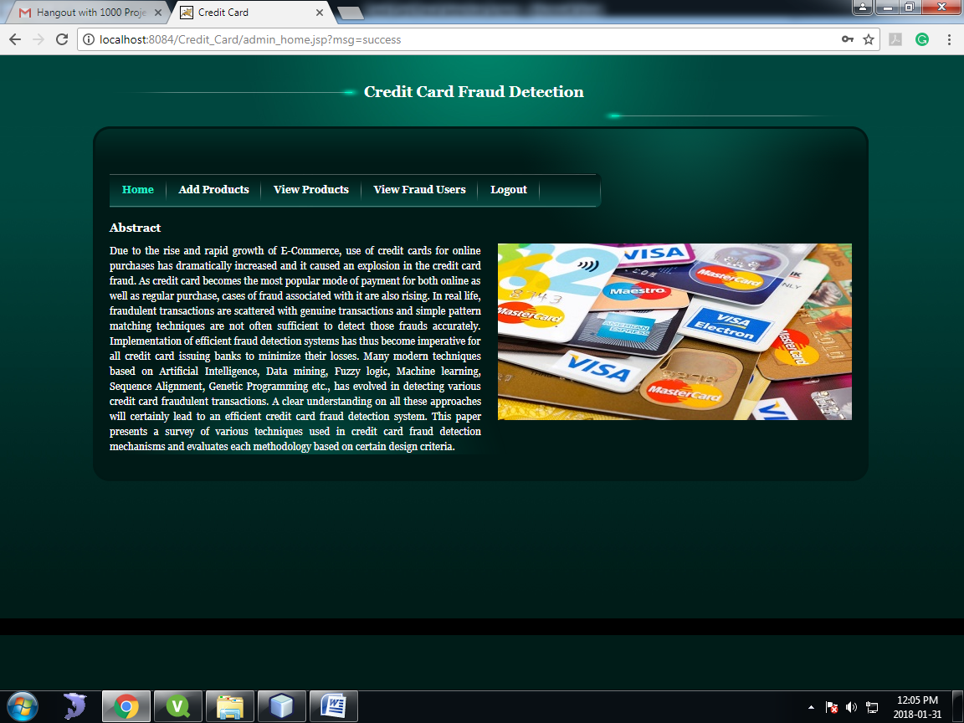

Fig: Admin Home



Fig: Add Products

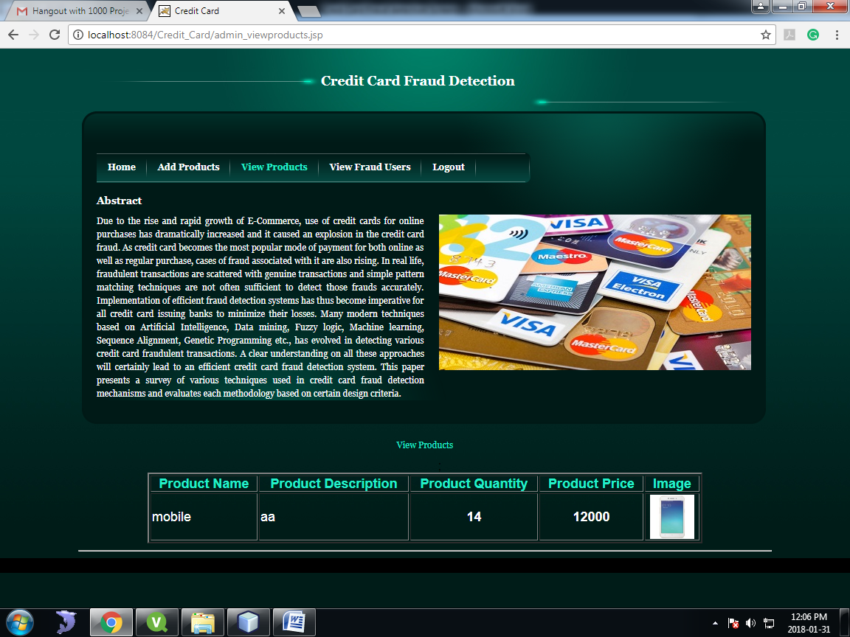

Fig: View Products

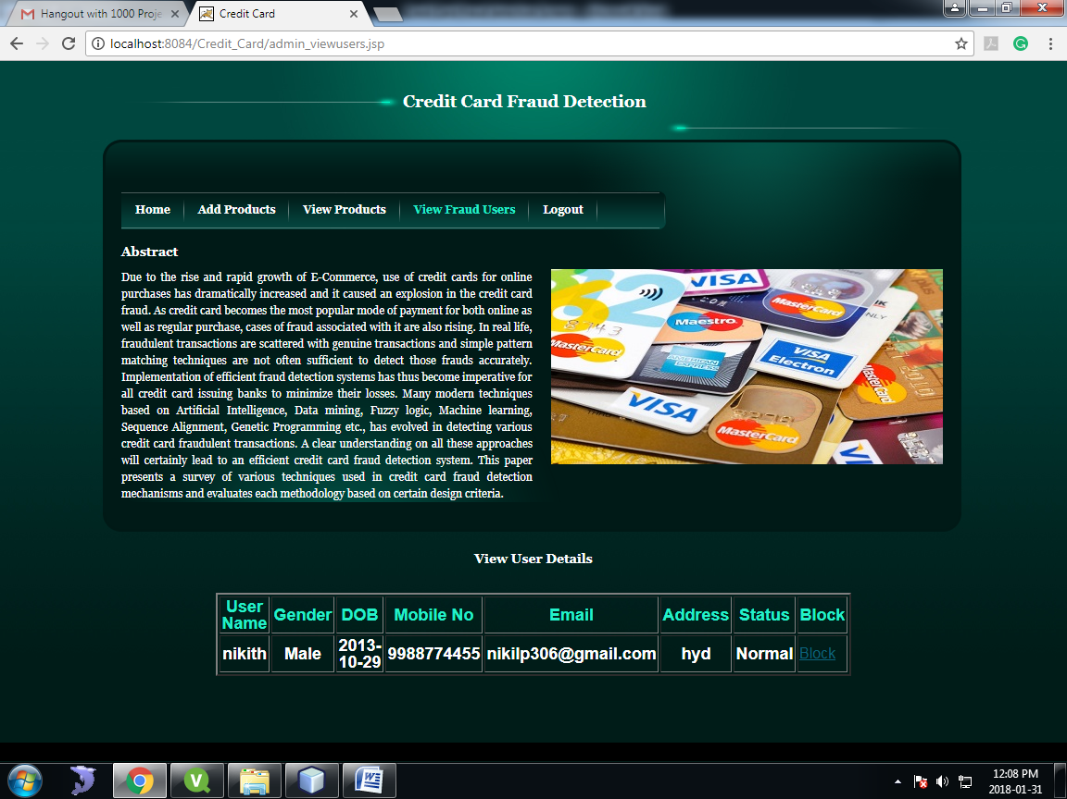

Fig: View Fraud Users

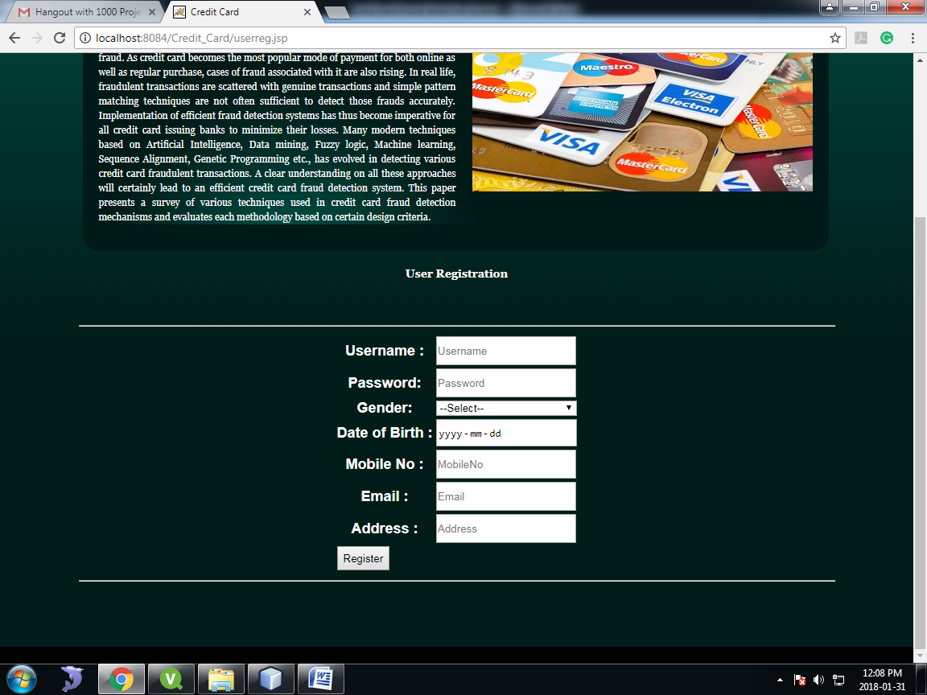

Fig: User Registration

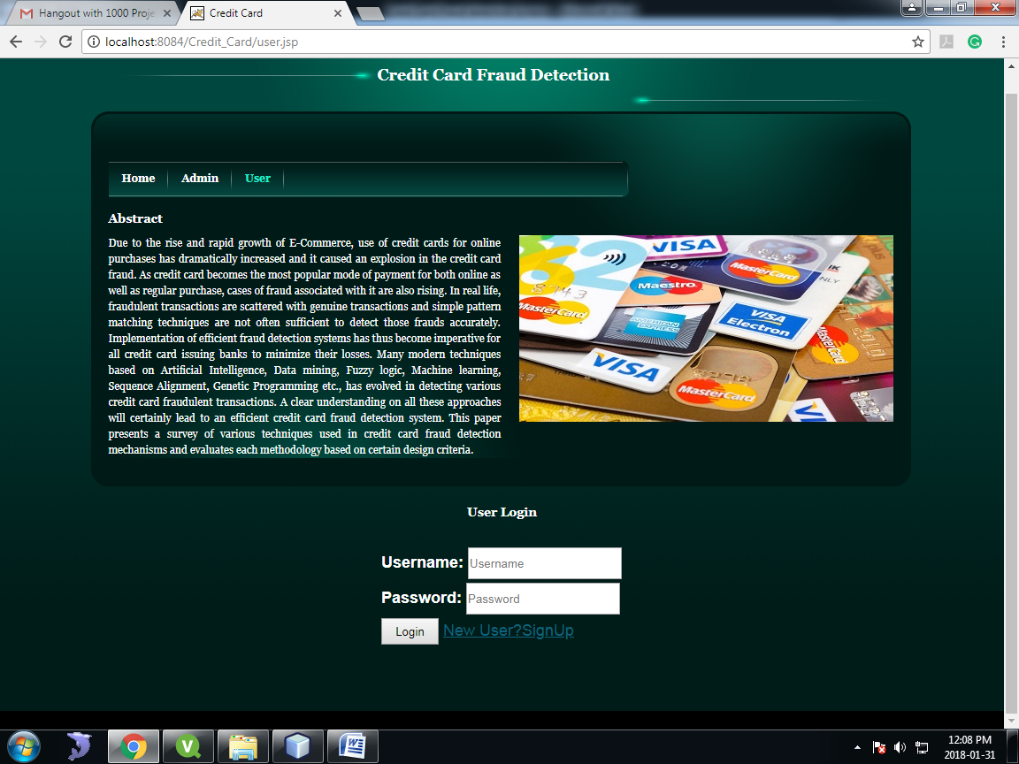

Fig: User Login

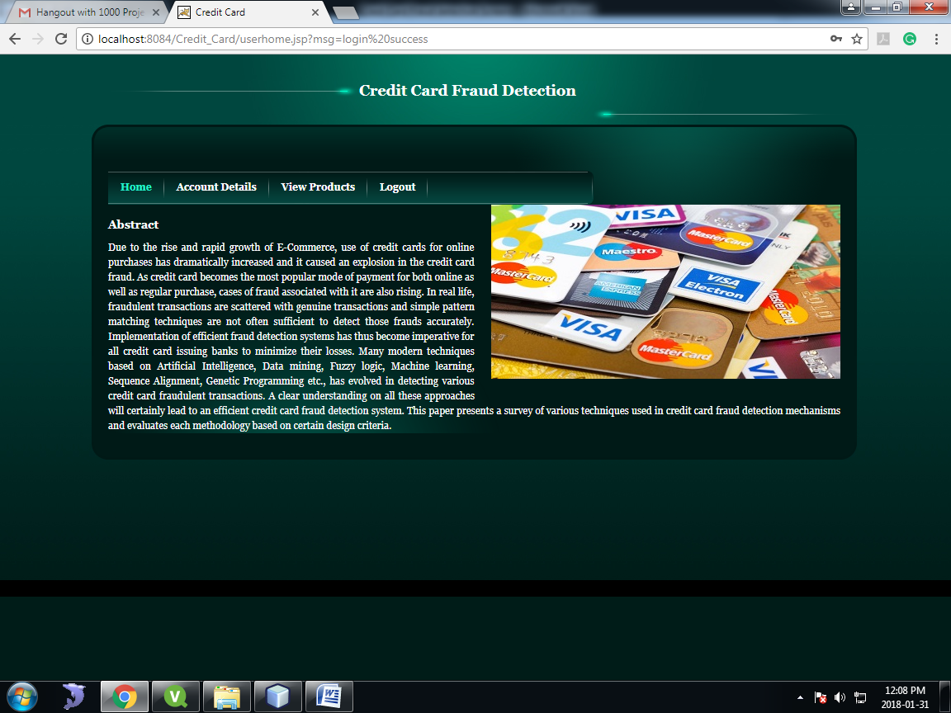

Fig: User Home



Fig: View Account Details



Fig: Add Card Details



Fig: Add Money to Card

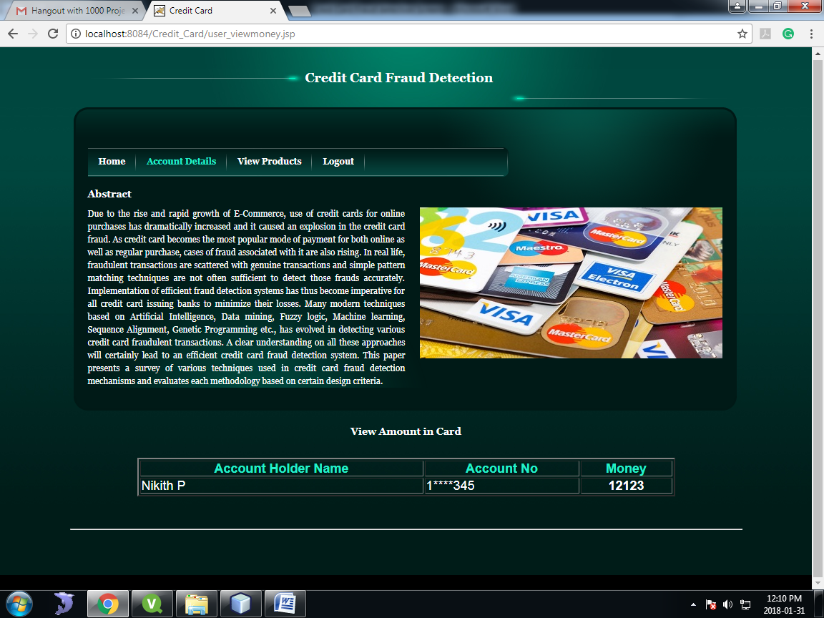

Fig: View Money

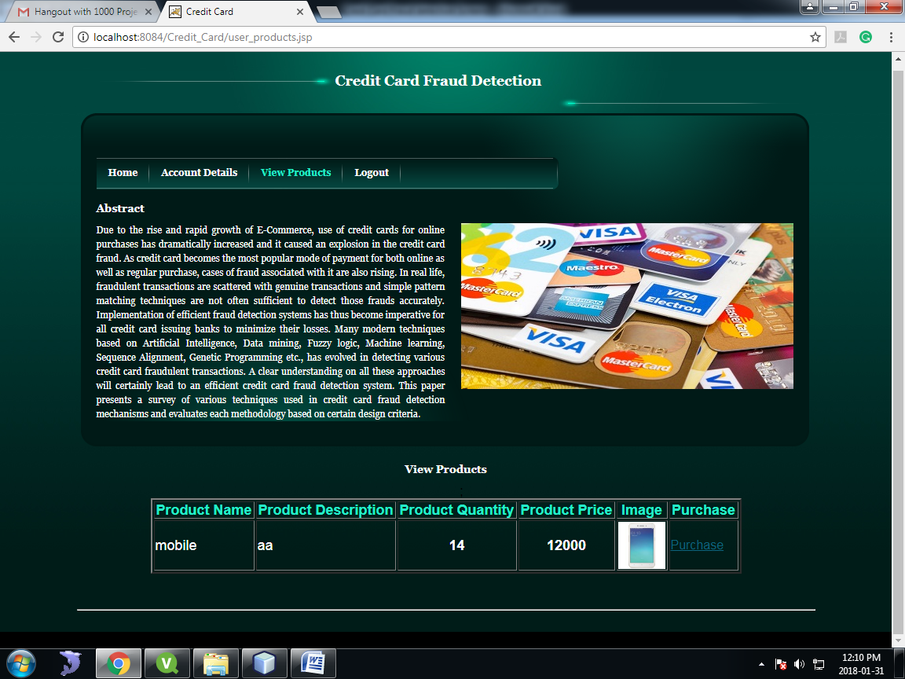

Fig: View Products



Fig: Select Quantity

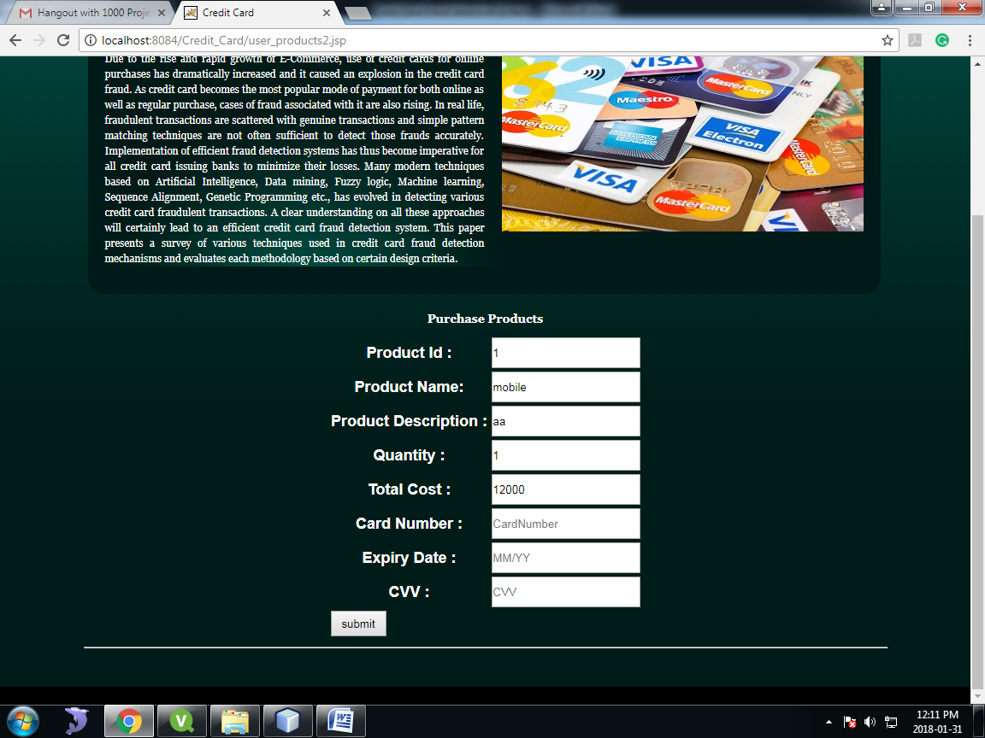

Fig: Enter Account Details